1. Intro and Purpose

**Name:** Vidhya Vaishnavi Devarajan

**Net ID:** vy9287

**Youtube video URL:** <https://youtu.be/r4SnyDsbM9M>

1. Demonstration of Application working
2. **/users/index**
3. Lists all the users of the Photo site from database, after successful migration.
4. User ID is displayed as a hyperlink, when clicked will be routed to the photos/index page

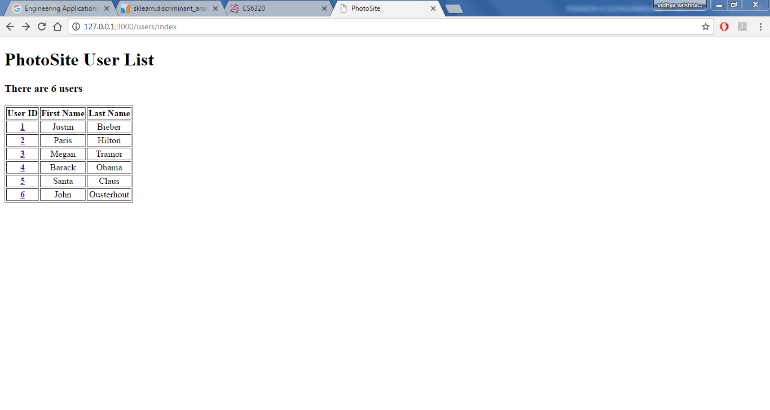

1. **Photos/index**
2. Displays the photos which belong to the user id which is passed in the param, along with “Created Time” and “Comments” from users on the photo displayed.

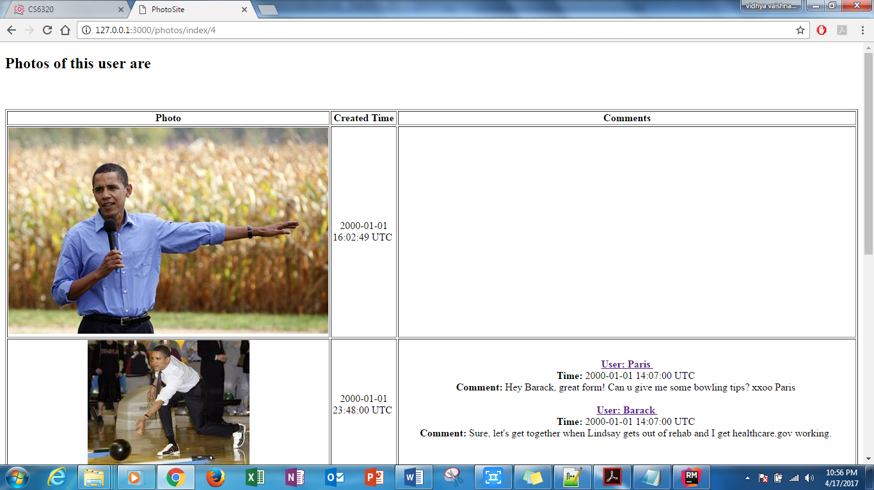

1. User name is displayed as a hyperlink, when clicked routes to photos/index and displays the Photo, Created Time and Comments of that user

When the “Paris” link is clicked, the below page will be displayed

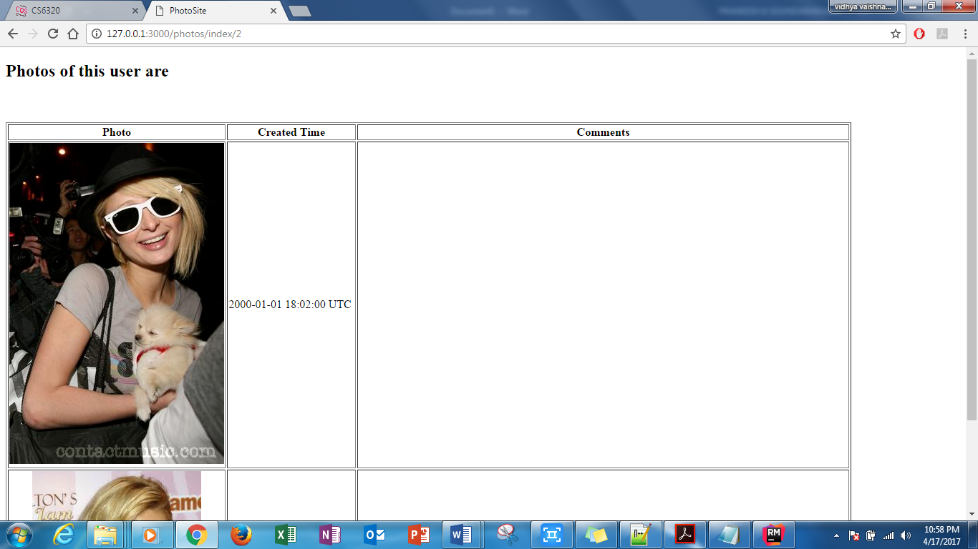

1. Discussion of anything NOT working

All requirements are implemented and working

1. All models are created

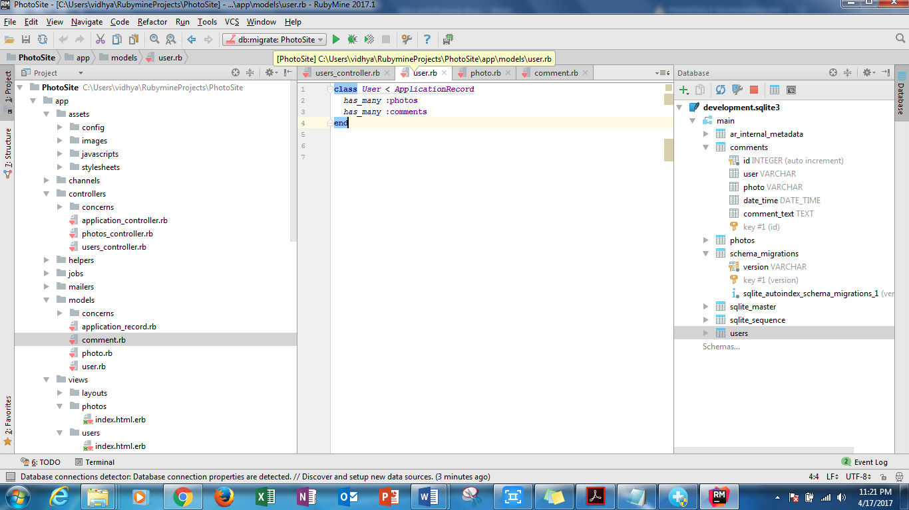

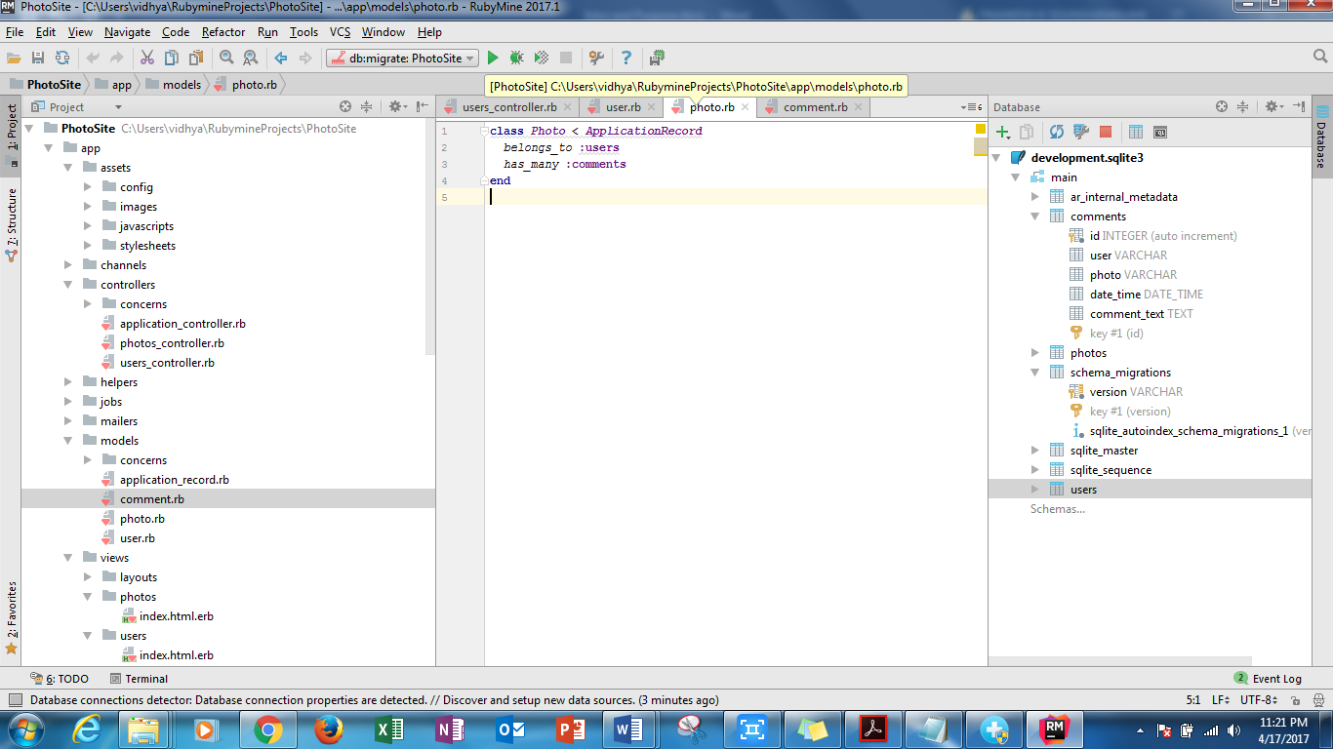

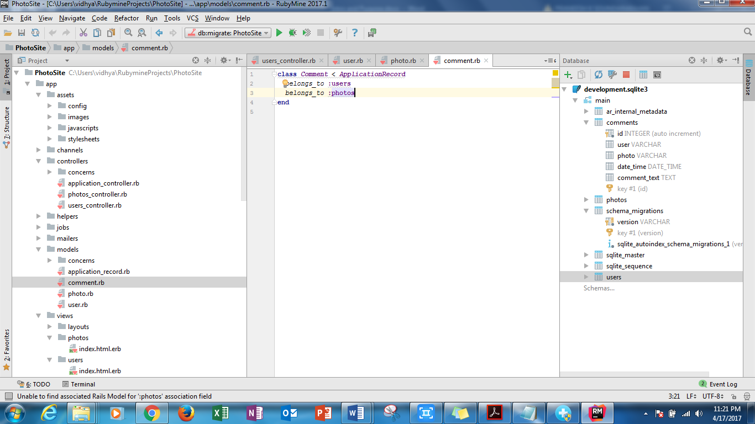

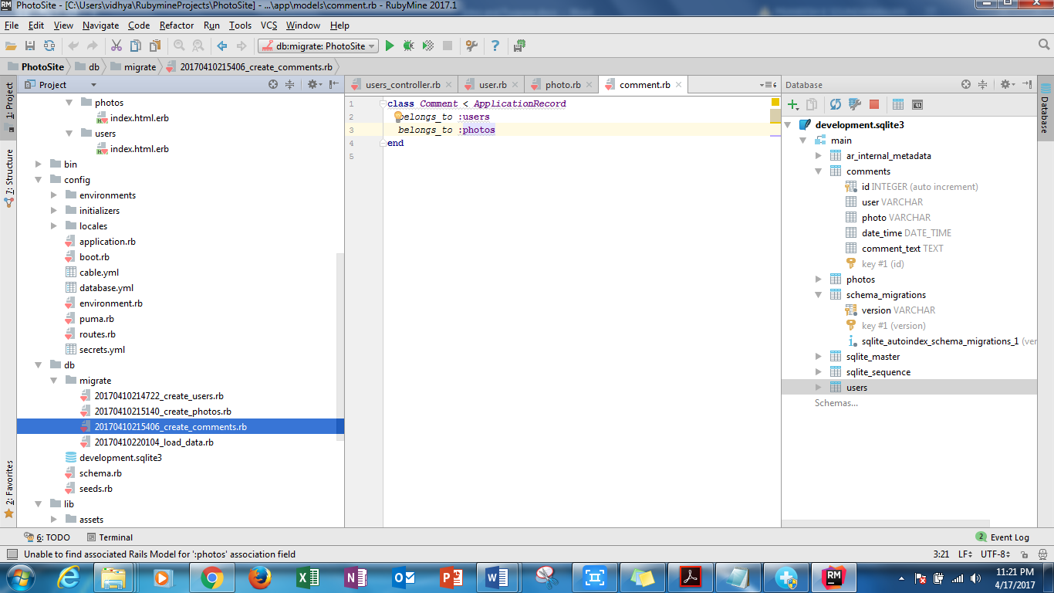

1. All Migrations are successful

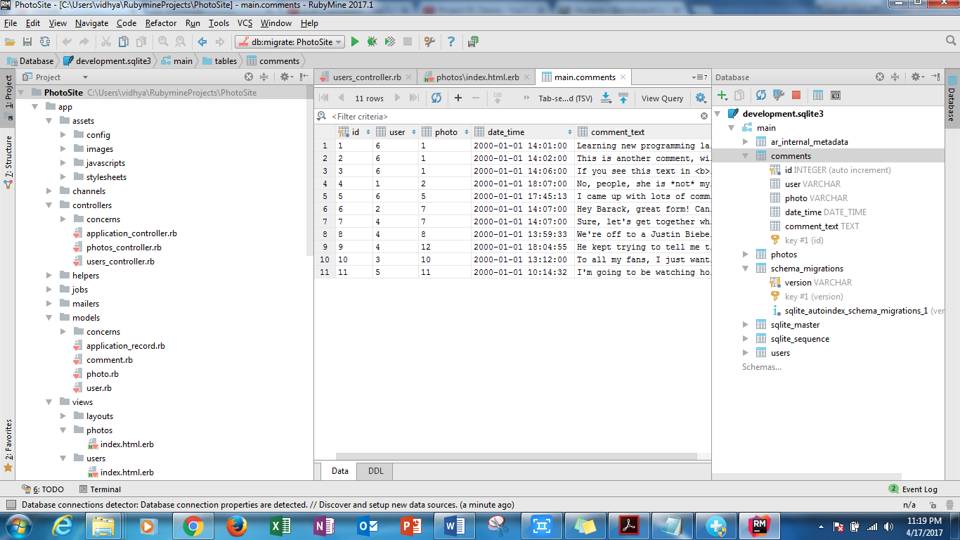

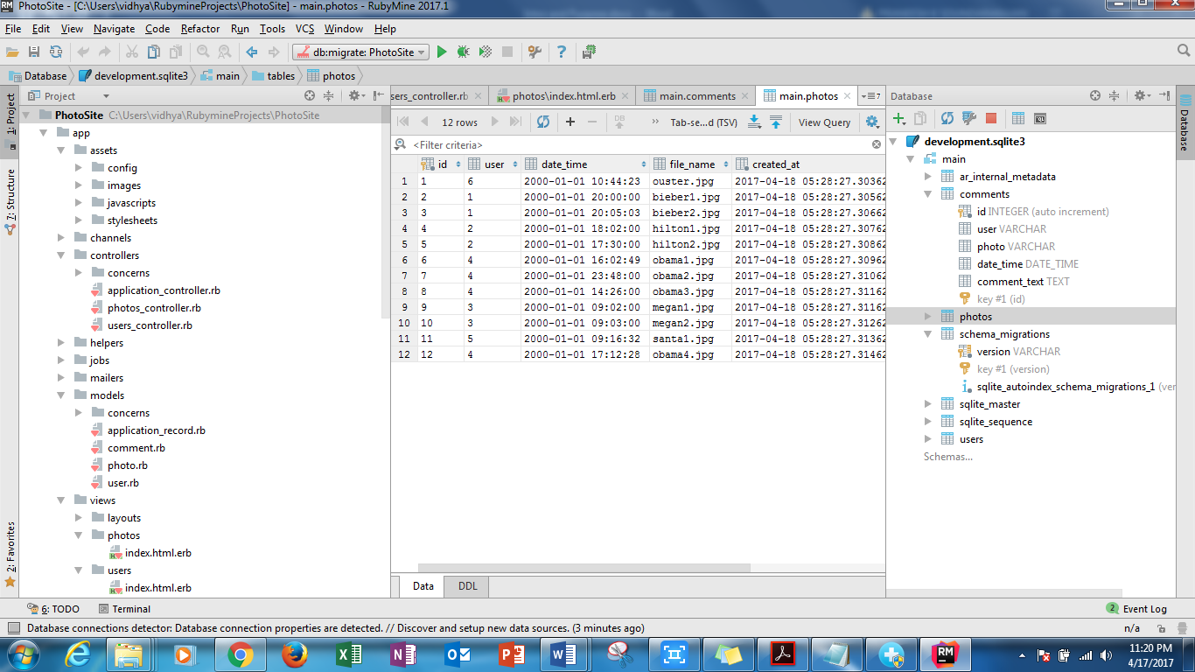

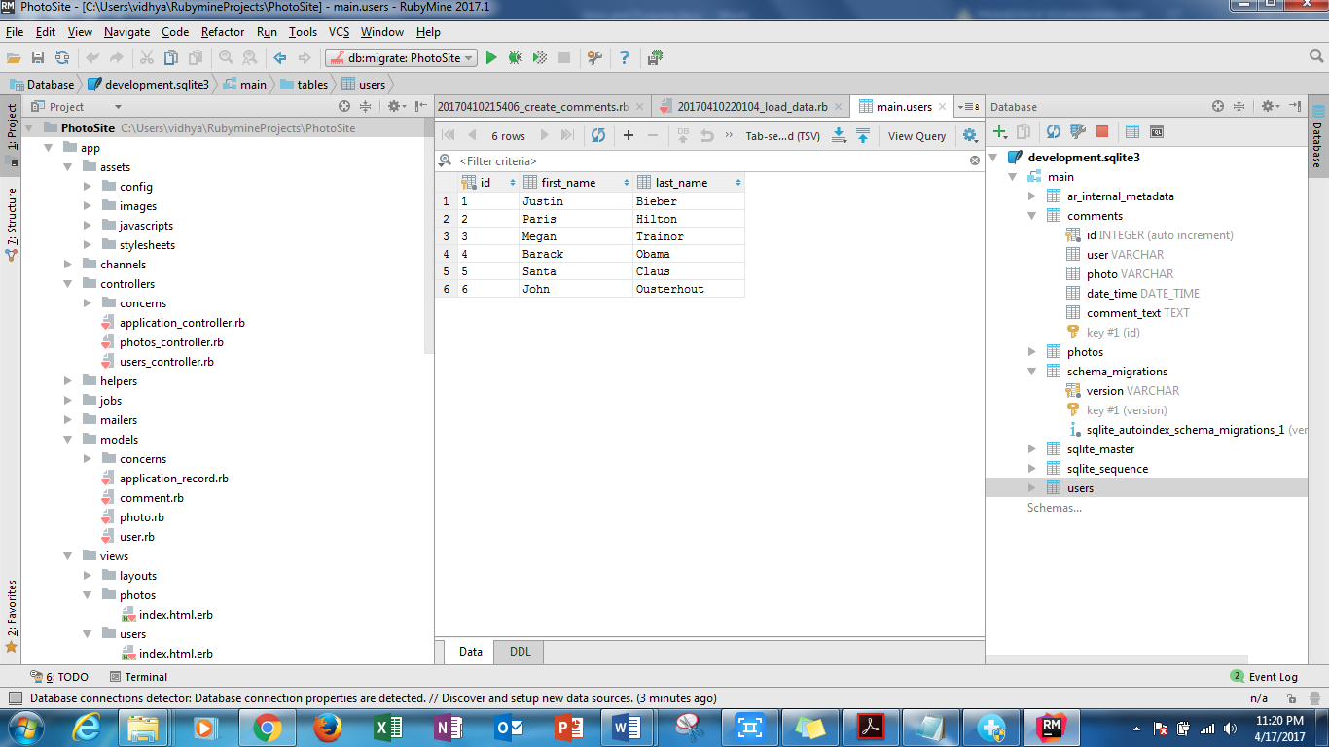

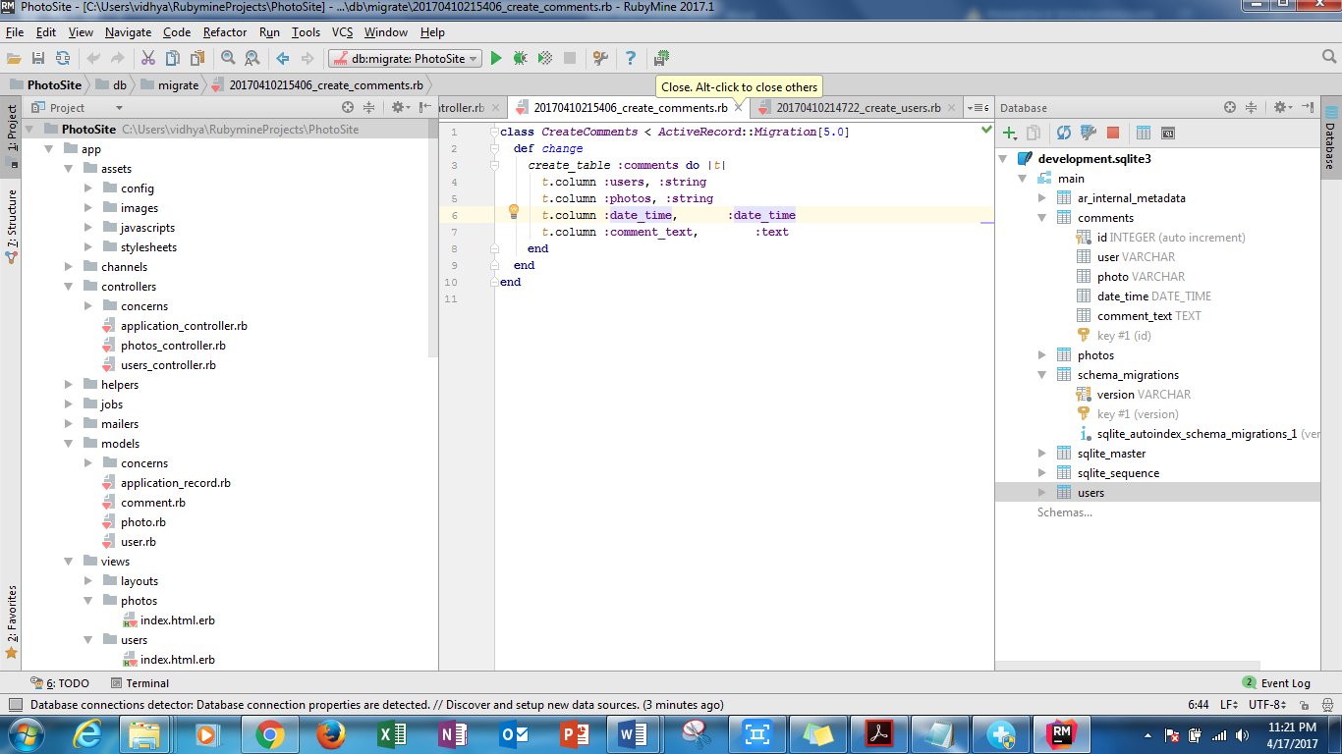

1. 2 views necessary for the 2 urls are created and the views are coded to display all users and photos

